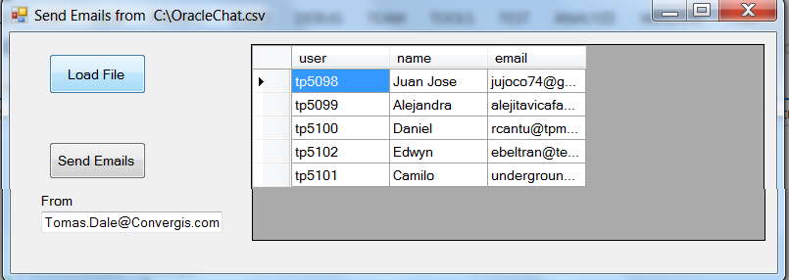

private DataTable ReadFile()

{

string sql2 = "Select * FROM [OracleChat.csv]";

string strPath = "c:\\";

string Cn1 = "Driver={Microsoft Text Driver (*.txt; *.csv)}; DefaultDir=" + strPath;

System.Data.Odbc.OdbcDataAdapter da = new OdbcDataAdapter(sql2, Cn1);

DataSet ds = new DataSet();

try

{

da.Fill(ds, "Files");

}

catch (Exception ss)

{

MessageBox.Show(ss.ToString());

}

return ds.Tables[0];

}

private void button1_Click(object sender, EventArgs e)

{

dataGridView1.DataSource = ReadFile();

}

private void button2_Click(object sender, EventArgs e)

{

string UserID;

string correo;

string Nombre;

DataTable dt = ReadFile();

foreach (DataRow dr in dt.Rows)

{

UserID = dr[0].ToString();

Nombre = dr[1].ToString();

correo = dr[2].ToString();

SendEmail(correo, Nombre, UserID);

}

MessageBox.Show("Finish");

}

protected void SendEmail(string SendTo, string agentName, string UserId)

{

try

{

MailMessage mail = new MailMessage();

SmtpClient SmtpServer = new SmtpClient("mailedc01");

SendTo = textBox1.Text; // CAMBIAR

string From = textBox1.Text;

mail.From = new MailAddress(From);

mail.To.Add(SendTo);

mail.Subject = "Oracle Chat Access";

mail.Body = "Hi "+ agentName + "\n\nYour credentials to access Oracle chat are\n\nUserID " + UserId + "\nPassword stream#1 \n\nRegards";

SmtpServer.Port = 25;

SmtpServer.Send(mail);

}

catch

{

MessageBox.Show("Error sending the emails");

}

}